Experiment 3
- Program to calculate square , square root and cube of a number.
Code:
num=8

echo "Given number is: $num"

square=$((num * num))
cube=$((num * num * num))
sqrt=$(echo "sqrt($num)" | bc)

echo "Square of $num is: $square"
echo "Square root of $num is: $sqrt"
echo "Cube of $num is: $cube"
Output:
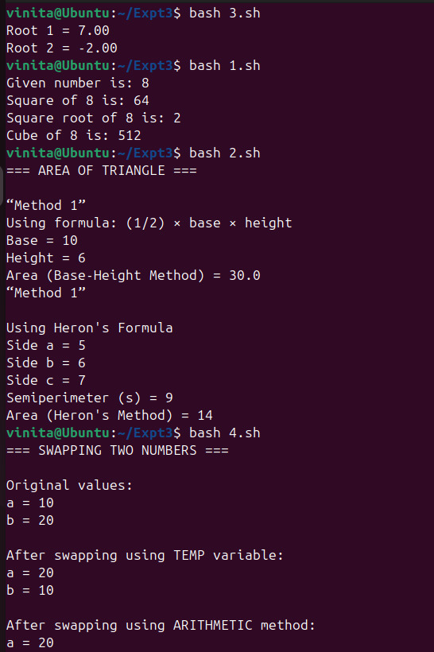

- Program to calculate area of triangle.
formula - ½*base*height
formula - semiperimeter – s= (a+b+c)/2
area = (s*(s-a)*(s-b)*(s-c))** 0.5
Code:
echo "=== AREA OF TRIANGLE ==="
base=10
height=6

echo ""
echo “Method 1”
echo "Using formula: (1/2) × base × height"
echo "Base = $base"
echo "Height = $height"

area1=$(echo "0.5 * $base * $height" | bc)

echo "Area (Base-Height Method) = $area1"

echo “Method 1”
a=5
b=6
c=7

echo ""
echo "Using Heron's Formula"
echo "Side a = $a"
echo "Side b = $b"
echo "Side c = $c"

s=$(echo "($a + $b + $c) / 2" | bc)

area2=$(echo "sqrt($s * ($s - $a) * ($s - $b) * ($s - $c))" | bc)

echo "Semiperimeter (s) = $s"
echo "Area (Heron's Method) = $area2"
Output:


- Program to solve quadratic equation. (ex. x²-5x-14)
formula - d = (b²)-(4*a*c)
x = (-b ±(d**0.5))/(2*a)
Code:
echo "=== QUADRATIC EQUATION SOLVER ==="

a=1
b=-5
c=-14

echo "Given equation: x² - 5x - 14 = 0"
echo "Value of a = $a"
echo "Value of b = $b"
echo "Value of c = $c"

d=$((b * b - 4 * a * c))

echo "Discriminant (d) = $d"

root1=$(echo "(-$b + sqrt($d)) / (2 * $a)" | bc)
root2=$(echo "(-$b - sqrt($d)) / (2 * $a)" | bc)

echo "First root = $root1"
echo "Second root = $root2"
Output:


- Program to swap two numbers. (using temp operator, using arithmetic operation)
Code:
echo "=== SWAPPING TWO NUMBERS ==="

# Initial values
a=10
b=20

echo ""
echo "Original values:"
echo "a = $a"
echo "b = $b"

# -------- Method 1: Using Temp Variable --------
temp=$a
a=$b
b=$temp

echo ""
echo "After swapping using TEMP variable:"
echo "a = $a"
echo "b = $b"

# Reset values for next method
a=10
b=20

# -------- Method 2: Without Temp (Arithmetic) --------
a=$((a + b))
b=$((a - b))
a=$((a - b))

echo ""
echo "After swapping using ARITHMETIC method:"
echo "a = $a"
echo "b = $b"
Output:


- Program to Calculate percentage.
Code:
echo "=== PERCENTAGE CALCULATION ==="

total=500
marks=425
echo "Total marks = $total"
echo "Obtained marks = $marks"
percentage=$((marks * 100 / total))
echo "Percentage = $percentage%"
Output:
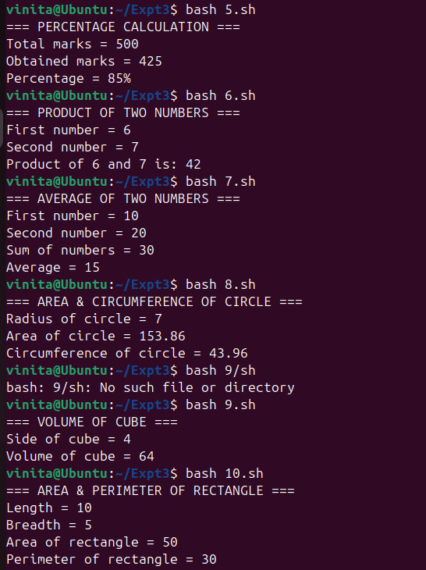

- Program to calculate product of two numbers.
Code:
echo "=== PRODUCT OF TWO NUMBERS ==="

a=6
b=7

echo "First number = $a"
echo "Second number = $b"

product=$((a * b))

echo "Product of $a and $b is: $product"
Output:


- Program to calculate Average of two numbers.
Code:
echo "=== AVERAGE OF TWO NUMBERS ==="

a=10
b=20

echo "First number = $a"
echo "Second number = $b"

sum=$((a + b))
average=$((sum / 2))

echo "Sum of numbers = $sum"
echo "Average = $average"
Output:


- Program to Calculate Area and Circumference of Circle.
Formula - Area = 0.5*3.14*r**2
Circumference = 2*3.14*r
Code:
echo "=== AREA & CIRCUMFERENCE OF CIRCLE ==="

r=7

echo "Radius of circle = $r"

area=$(echo "3.14 * $r * $r" | bc)
circumference=$(echo "2 * 3.14 * $r" | bc)

echo "Area of circle = $area"
echo "Circumference of circle = $circumference"
Output:


- Program to calculate volume of cube
Formula - volume = a**3
Code:
echo "=== VOLUME OF CUBE ==="

a=4

echo "Side of cube = $a"

volume=$((a * a * a))

echo "Volume of cube = $volume"
Output:


- Program to calculate area and perimeter of rectangle .
Formula - area = l * b
perimeter = 2*(l+b)
Code:
echo "=== AREA & PERIMETER OF RECTANGLE ==="

l=10
b=5

echo "Length = $l"
echo "Breadth = $b"

area=$((l * b))
perimeter=$((2 * (l + b)))

echo "Area of rectangle = $area"
echo "Perimeter of rectangle = $perimeter"
Output:


- Program to calculate Area and Perimeter of Parallelogram.
Formula - area = b * h
perimeter = 2*(b+h)
Code:
echo "=== AREA & PERIMETER OF PARALLELOGRAM ==="

b=8
h=5
side=6

echo "Base = $b"
echo "Height = $h"
echo "Side = $side"

area=$((b * h))
perimeter=$((2 * (b + side)))

echo "Area of parallelogram = $area"
echo "Perimeter of parallelogram = $perimeter"
Output:
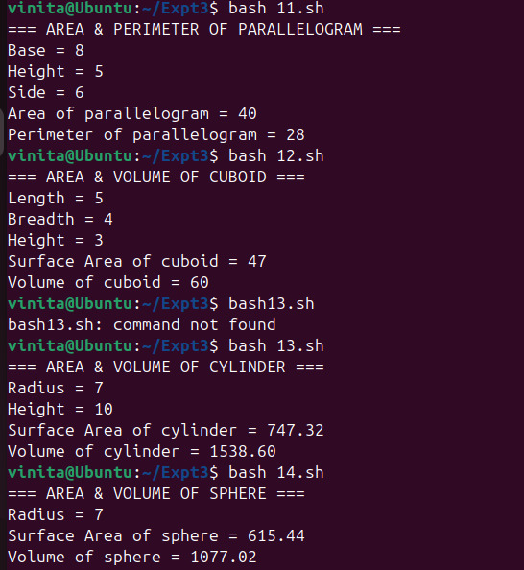

- Program to calculate Area and Volume of Cuboid .
Formula - area = (l*b+b*h+h*l)
volume = l*b*h
Code:
echo "=== AREA & VOLUME OF CUBOID ==="

l=5
b=4
h=3

echo "Length = $l"
echo "Breadth = $b"
echo "Height = $h"

area=$((l*b + b*h + h*l))
volume=$((l * b * h))

echo "Surface Area of cuboid = $area"
echo "Volume of cuboid = $volume"
Output:


- Program to calculate Area and Volume of Cylinder
Formula - area = 2*p*r*(h+r)
volume = p*r²*h
Code:
echo "=== AREA & VOLUME OF CYLINDER ==="

r=7
h=10

echo "Radius = $r"
echo "Height = $h"

area=$(echo "2 * 3.14 * $r * ($h + $r)" | bc)
volume=$(echo "3.14 * $r * $r * $h" | bc)

echo "Surface Area of cylinder = $area"
echo "Volume of cylinder = $volume"
Output:


- Program to calculate Area and Volume of Sphere
Formula - area = 4*p*r²
volume = 4/3*p*r³
Code:
echo "=== AREA & VOLUME OF SPHERE ==="

r=7

echo "Radius = $r"

area=$(echo "4 * 3.14 * $r * $r" | bc)
volume=$(echo "4/3 * 3.14 * $r * $r * $r" | bc)

echo "Surface Area of sphere = $area"
echo "Volume of sphere = $volume"
Output:


- Write a shell script to calculate the Factorial of a number entered by user.
Code:
echo "=== FACTORIAL CALCULATION ==="

echo -n "Enter a number: "
read num

fact=1

for (( i=1; i<=num; i++ ))
do
fact=$((fact * i))
done

echo "Factorial of $num is: $fact"
Output:
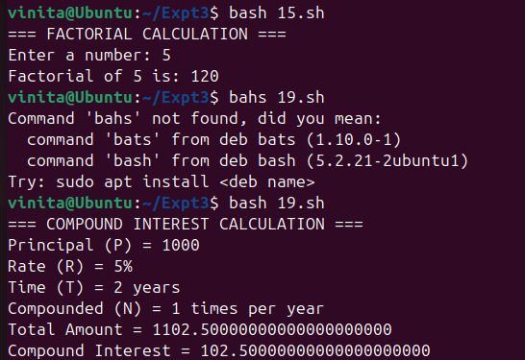

- Create a script that accepts input in GB and outputs its equivalent value in MB and
KB.
Code:
echo "=== GB TO MB & KB CONVERSION ==="

echo -n "Enter value in GB: "
read gb
mb=$((gb * 1024))
kb=$((mb * 1024))
echo "Given value in GB = $gb"
echo "Equivalent value in MB = $mb"
echo "Equivalent value in KB = $kb"
Output:
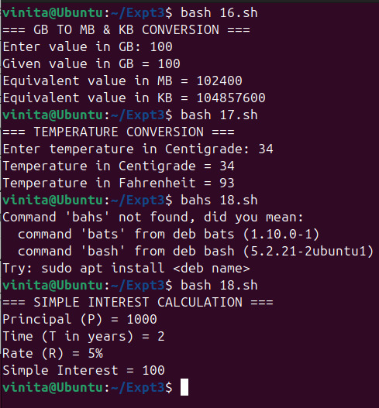

- Write a script that converts Centigrade to Fahrenheit.
Hint: Use the formula F = C x (9/5) + 32. You'll have to use bc command here.
Code:
echo "=== TEMPERATURE CONVERSION ==="
echo -n "Enter temperature in Centigrade: "
read c
f=$(echo "$c * 9 / 5 + 32" | bc)

echo "Temperature in Centigrade = $c"
echo "Temperature in Fahrenheit = $f"
Output:


- Program to calculate simple interest.
Formula - SI = (P*T*R)/100
Code:
echo "=== SIMPLE INTEREST CALCULATION ==="
P=1000
T=2
R=5
echo "Principal (P) = $P"
echo "Time (T in years) = $T"
echo "Rate (R) = $R%"
SI=$((P * T * R / 100))
echo "Simple Interest = $SI"
Output:


- Program to calculate compound interest.
Formula - CI = P(1+R/N) ^{N*T}
Code:
echo "=== COMPOUND INTEREST CALCULATION ==="
P=1000 # Principal
R=5 # Rate of interest
T=2 # Time (years)
N=1 # Number of times interest applied per year
echo "Principal (P) = $P"
echo "Rate (R) = $R%"
echo "Time (T) = $T years"
echo "Compounded (N) = $N times per year"

amount=$(echo "$P * (1 + $R / (100 * $N)) ^ ($N * $T)" | bc -l)
CI=$(echo "$amount - $P" | bc -l)
echo "Total Amount = $amount"
echo "Compound Interest = $CI"
Output:


